**Ideation Phase**

**Brainstorm & Idea Prioritization Template**

| Date | 24 June 2025 |
| --- | --- |
| Team ID | LTVIP2025TMID20422 |
| Project Name | LAPTOP REQUEST CATALOG ITEM |
| Maximum Marks | 4 Marks |

**Brainstorm & Idea Prioritization Template:**

For the **'Laptop Request Catalog Item'** project, our **Brainstorming and Idea Prioritization** efforts will focus on transforming the current manual and delay-prone laptop request process into a quick, efficient, and dynamic ServiceNow Service Catalog experience. We will collaboratively generate a comprehensive range of ideas for variables, dynamic UI policies, approval workflows, and user guidance, prioritizing *volume over value* initially to capture every possible enhancement for accurate data collection and an intuitive user interface. This will include exploring how to best implement dynamic form behavior, clear instructions, and reset functionality. Subsequently, through a structured prioritization process, we will evaluate these ideas to select the most impactful and feasible solutions for development, ensuring the project delivers a truly user-centric and error-reducing solution that significantly improves employee satisfaction and operational efficiency.

**Step-1: Team Gathering, Collaboration and Select the Problem Statement**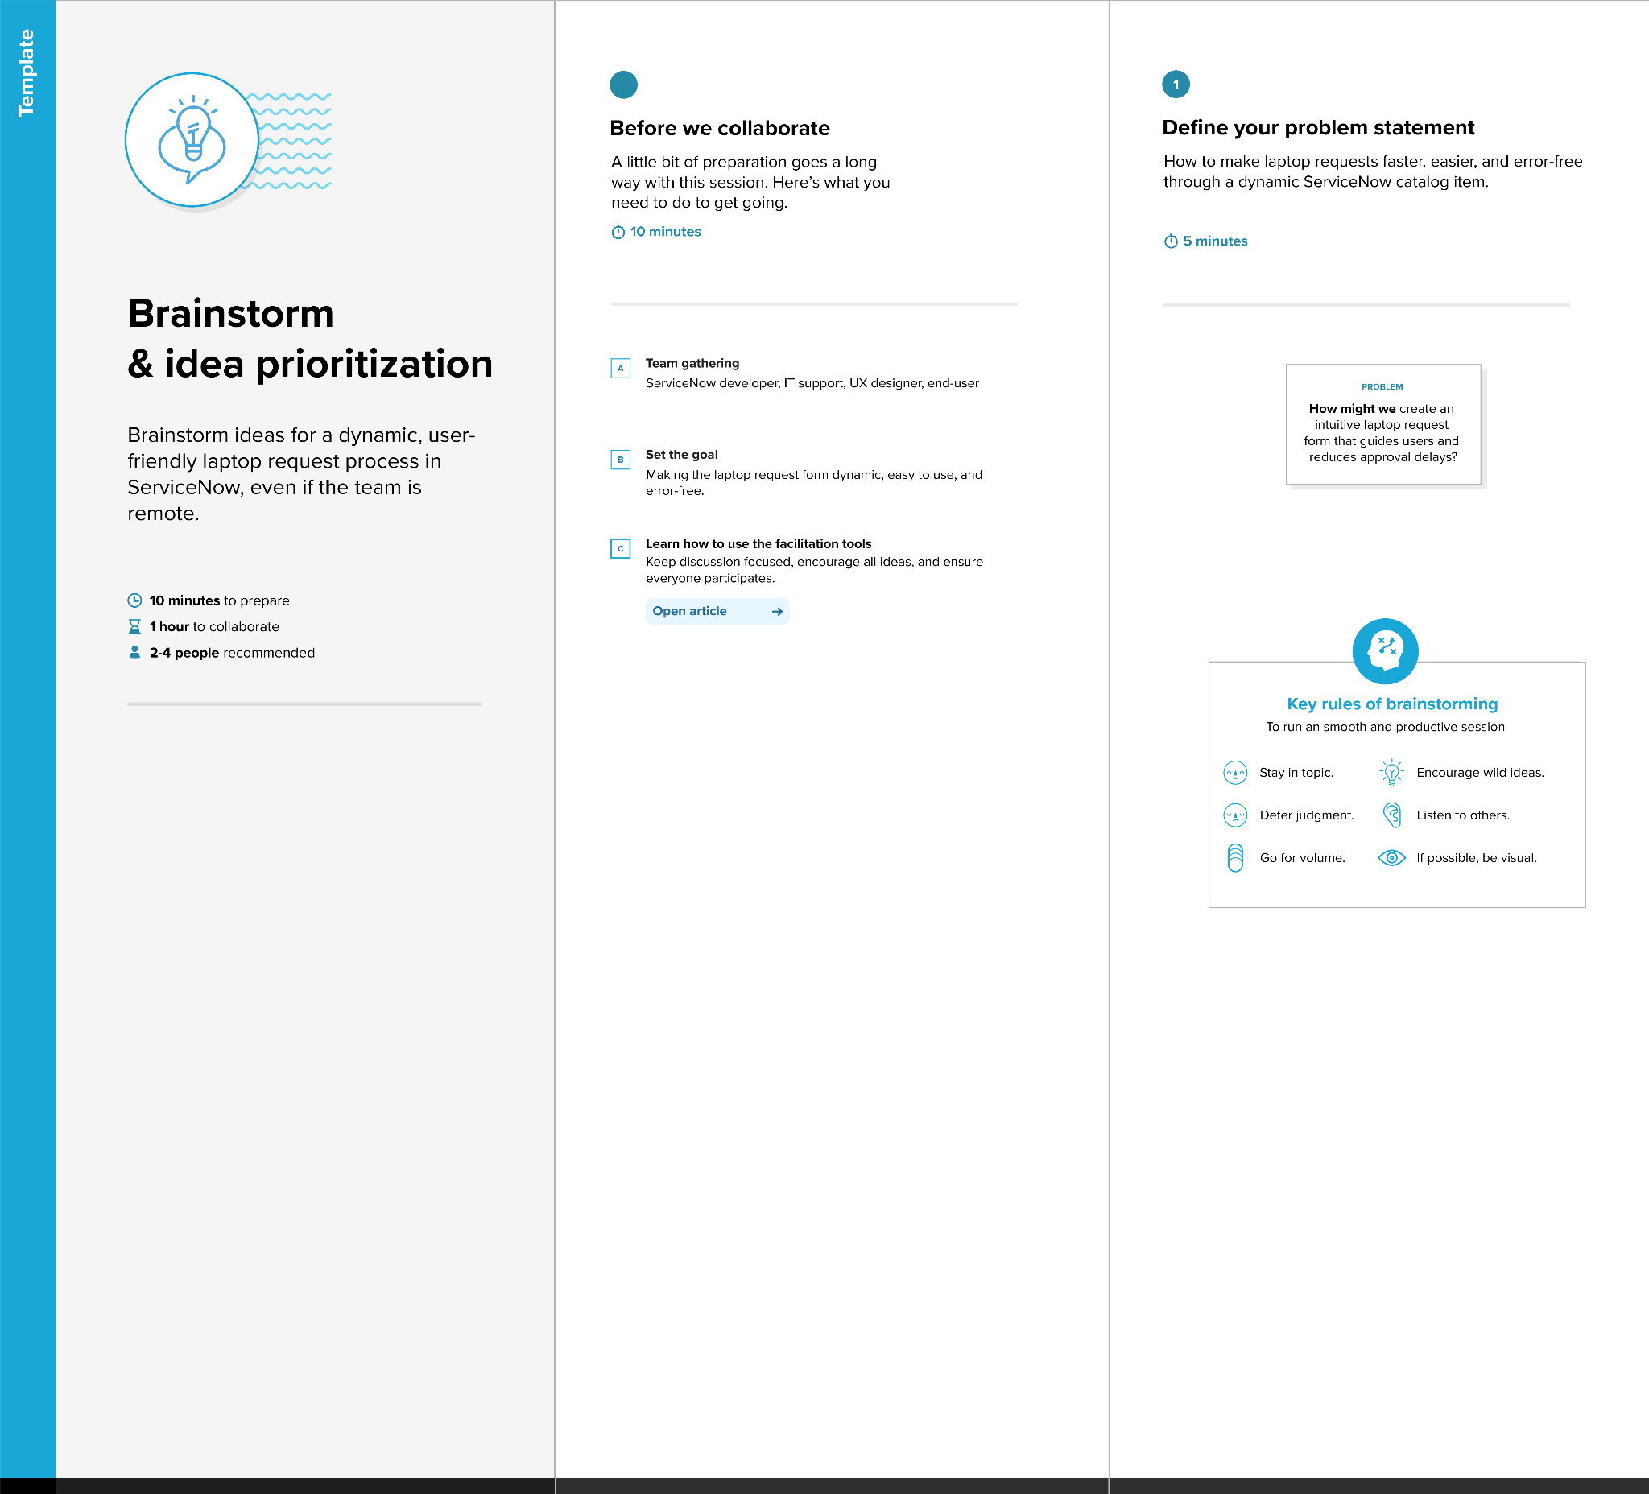

**Step-2: Brainstorm, Idea Listing and Grouping**

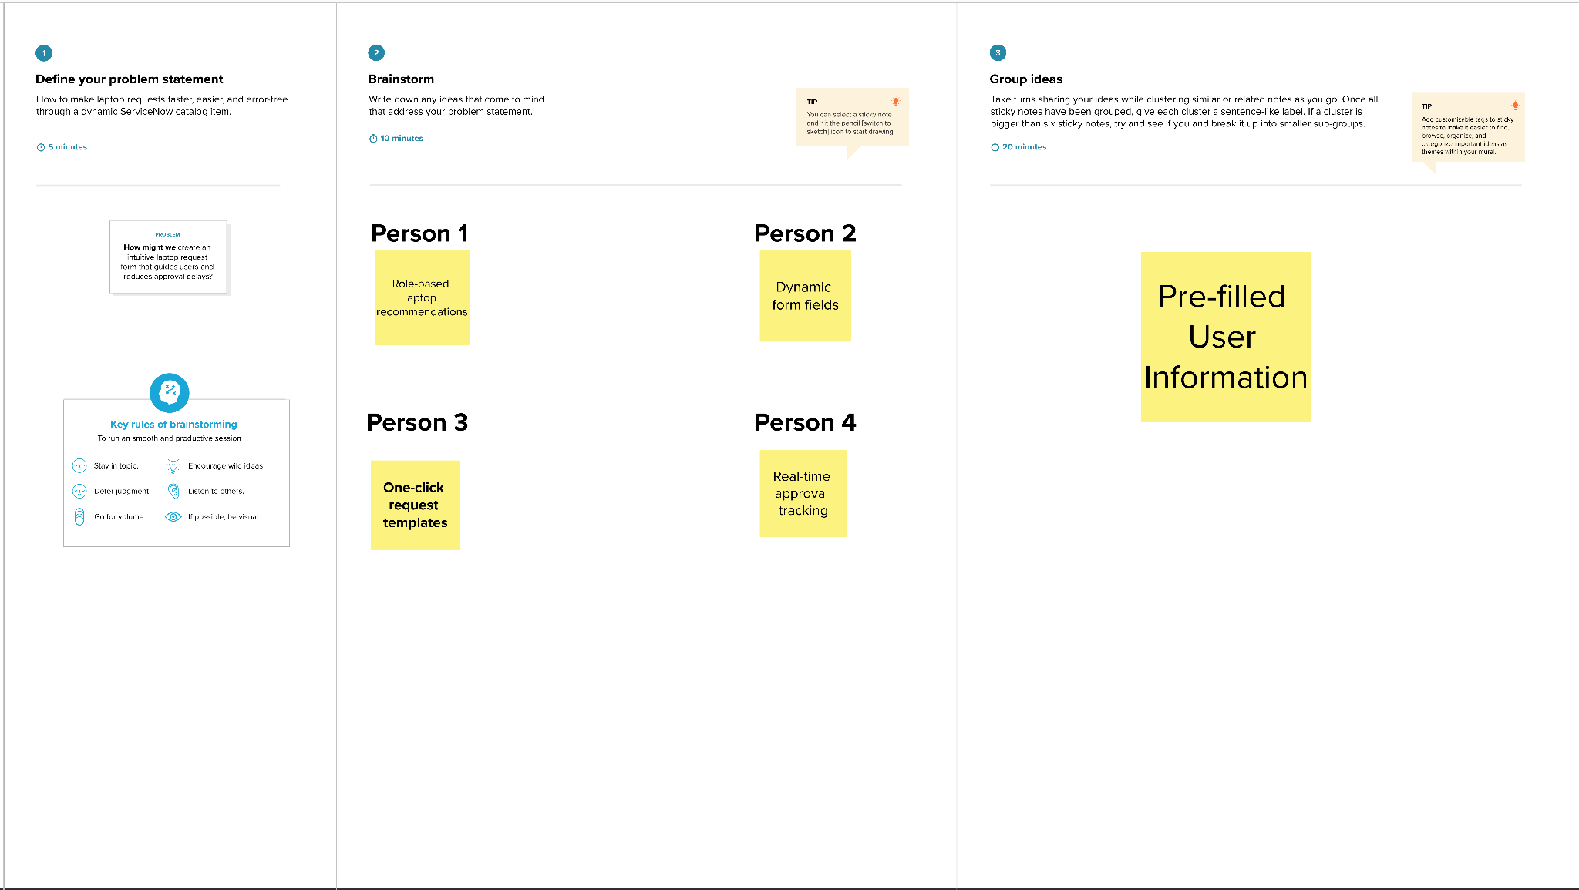

**Step-3: Idea Prioritization**

